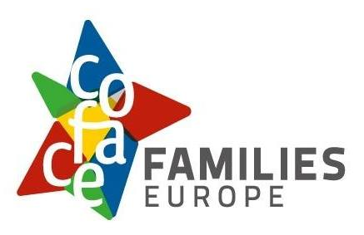

What COFACE Families Europe stands for
Easy-to-read text
‘Easy-to-read’ is information
that is written in a simple and clear way
so that people with intellectual disabilities
and all people can understand it.
You can find more information about easy-to-read
at www.inclusion-europe.eu/easy-to-read.

Who we are
We are ‘COFACE Families Europe’.
We are an organisation that works for the rights
of all families in Europe since 1958.
In short, we are called ‘COFACE’.

At COFACE, we want to make sure
that all families can enjoy
a good, healthy and safe life.
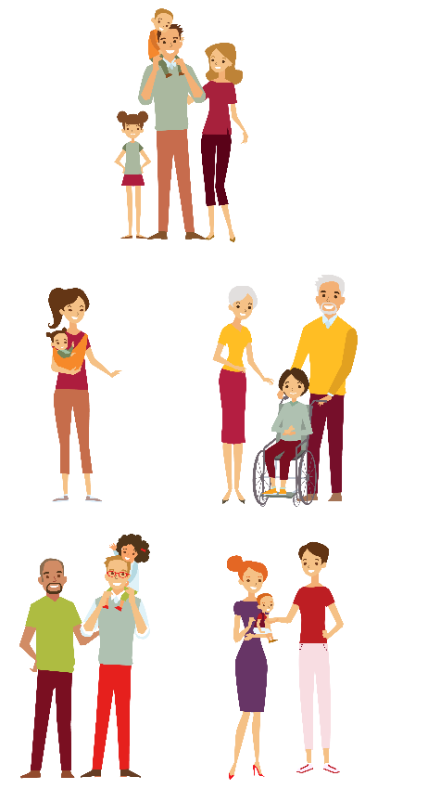
We often think of families
as parents and children.
But families can have many forms.
For example,
there are children who grow up
only with one parent or with their grandparents.
There are also children who grow up
with two fathers or two mothers.

At COFACE, we believe that:
- All forms of families are important
and they have the same rights.
No family should be left out
just because it has a different form.

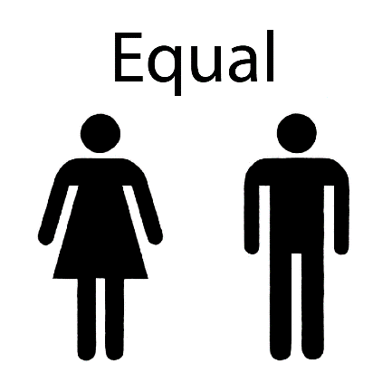
- Men and women are equal
and they have the same rights and duties
when they become parents.

- All families have the right
to enjoy a good life.

- All families have the right
to speak up for themselves.
- Countries should give support to families in need
so they can have a good life and take part in the community.
- It is important that family members of different ages
can learn from each other.

Our members
COFACE has more than 50 members
in 23 countries in Europe.

Our members are organisations which work
to help families to have a good and safe life
and especially those in higher risk of being left out.
For example:
- Families who are very poor.
- Single parents who raise their child alone.
- Families with children with disabilities.
- Families who live in places away from the community
and do not have easy access to hospitals
and other important things.
You can check the list of our members per country
by clicking here

How we work
Once per year, we organise a big meeting with all our members.
This way we can talk about important topics for families in Europe
and plan our work to make things better.
We call this meeting ‘General Assembly’.

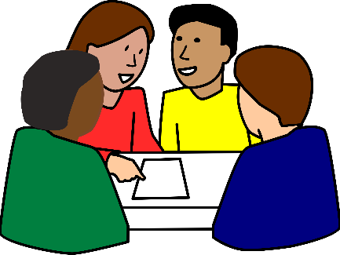
We also have:
- The ‘Administrative Council’.
This is a group of people
who make decisions for COFACE.
- The ‘Executive Bureau’
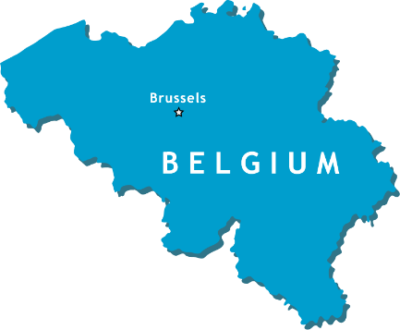
This is a group of people who work
to make sure these decisions
are put into practice.
- The ‘Secretariat’
This is a group of people who work
in our office in Brussels
and do the every-day work of COFACE.
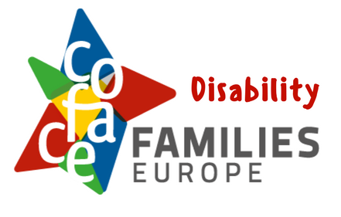
In 1998, we made
the ‘COFACE Disability Platform’.
This is a group of more than 20 organisations that came together to make things better
for people with disabilities and their families.
For example, they push countries to:
- Listen to the needs
of people with disabilities and their families
and respect their rights.
- Give them the right support to enjoy their lives
and make their own choices.

What we work for
At COFACE, we work to make sure that countries:
- Understand the needs of all families,
- Respect their rights,
- Support them to have a good life.
We want to have a society
in which all families can take part and enjoy their rights.

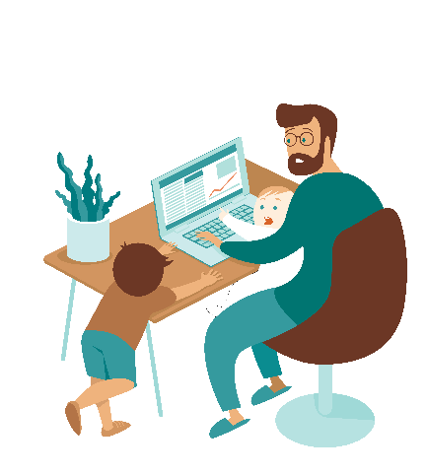
We want to make sure that:
- Parents who work get the right support
to be able to take care of their families.
For example, they should be able
to take time off work
when their children are sick.

- Women and men who are parents
have the same rights and duties.
It should not be expected
only from one of them
to care for their child.

- People with disabilities and their families
get the support they need
to be independent
and make their own choices in life.
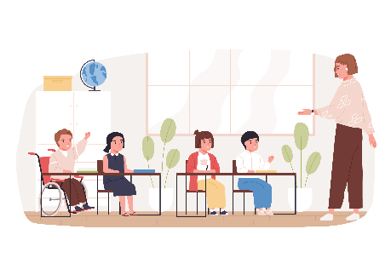
- All children have the chance
to go to school and take part in activities
with other children.
They should not be left out
if they have a disability, they are poor
or anything else.
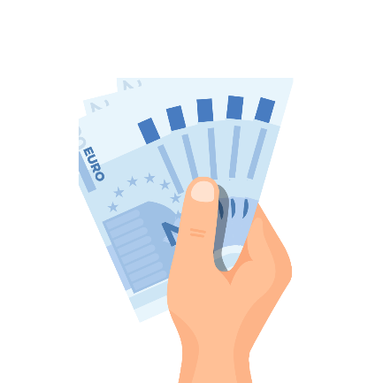
- Children have the right to grow
in a safe and healthy family and society.
- Countries spend their money
to make things better
for their people and the planet.

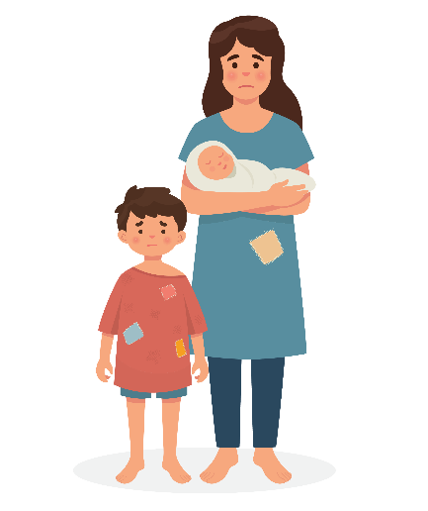
- Countries help families in need
like those who are very poor or left out.

- All families have access to technology
like computers or tablets.
Using technology can help them
to work, study, learn new skills
and stay in contact with other people.

Join us!
At COFACE, we think it is important to come together,
share our experiences and learn from each other.
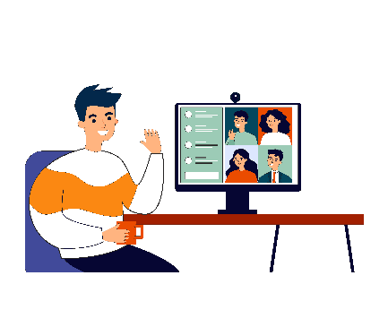
That is why in January 2021 we started organising the ‘Breakfast Bytes Webinars’.
These are meetings that happen online
every month.

People working with families and children
talk in these meetings about their experience and explain why it is important for families
to get the right support.

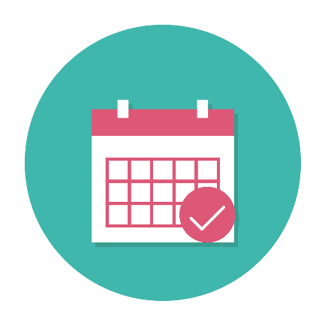
Everyone who is interested in these topics
can take part in these meetings.

You can find more information
about these online meetings here

More information
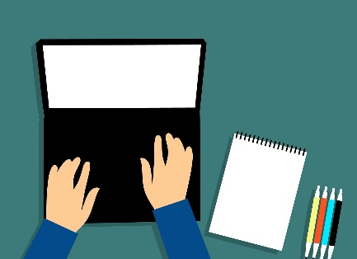
If you want to know more about our work
or if you have any questions,
you can send us an email at
secretariat@coface-eu.org.

