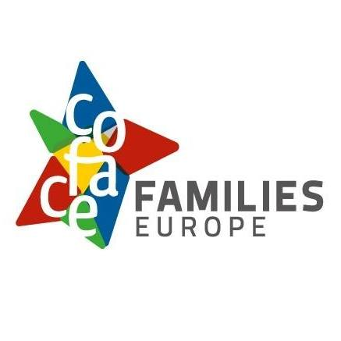

# Supporting family carers

**Easy-to-read version**

Easy-to-read is information

that is written in a simple way   
so that all people can understand it.

You can find more information at:

[www.inclusion-europe.eu/easy-to-read](http://www.inclusion-europe.eu/easy-to-read).

## Who we are

We are ‘COFACE Families Europe’.

We are an organisation that fights   
for the rights of all families in Europe.

In short, we are called ‘COFACE’.

At COFACE,   
we believe that all families   
should have the same chances   
to enjoy a good, healthy and safe life.

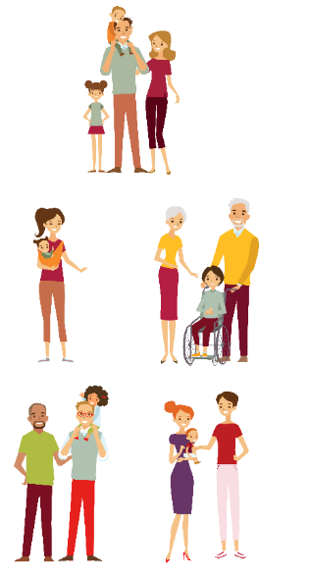   

### What this text is about

At COFACE, we wrote a text to talk about   
the important role of family carers   
and to ask countries to support them.

We called this text   
the ‘European Charter for family carers’.

This is an easy-to-read version of this text.

In the next few pages, we will explain:

What does it mean to be a family carer?

What is the situation of family carers in Europe?

What should countries do better   
to support family carers?

### The role of family carers

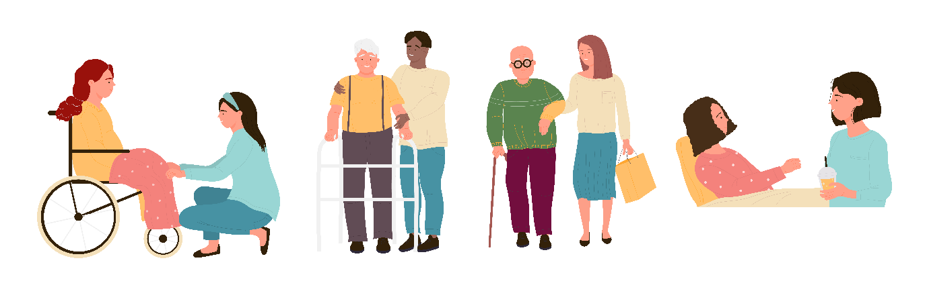

All people may need to be looked after at some point in their lives.

For example:

* When they have a disability;
* When they get sick;
* When they get older;
* When they have an accident.

Sadly, most countries in Europe do not give enough support to people who need it.

Their families alone have to look after them, with little or no support from the countries.

A person who regularly looks after another family member is called a ‘family carer’.

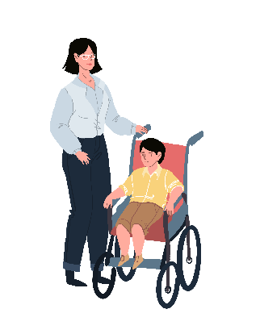For example, a family carer can be:

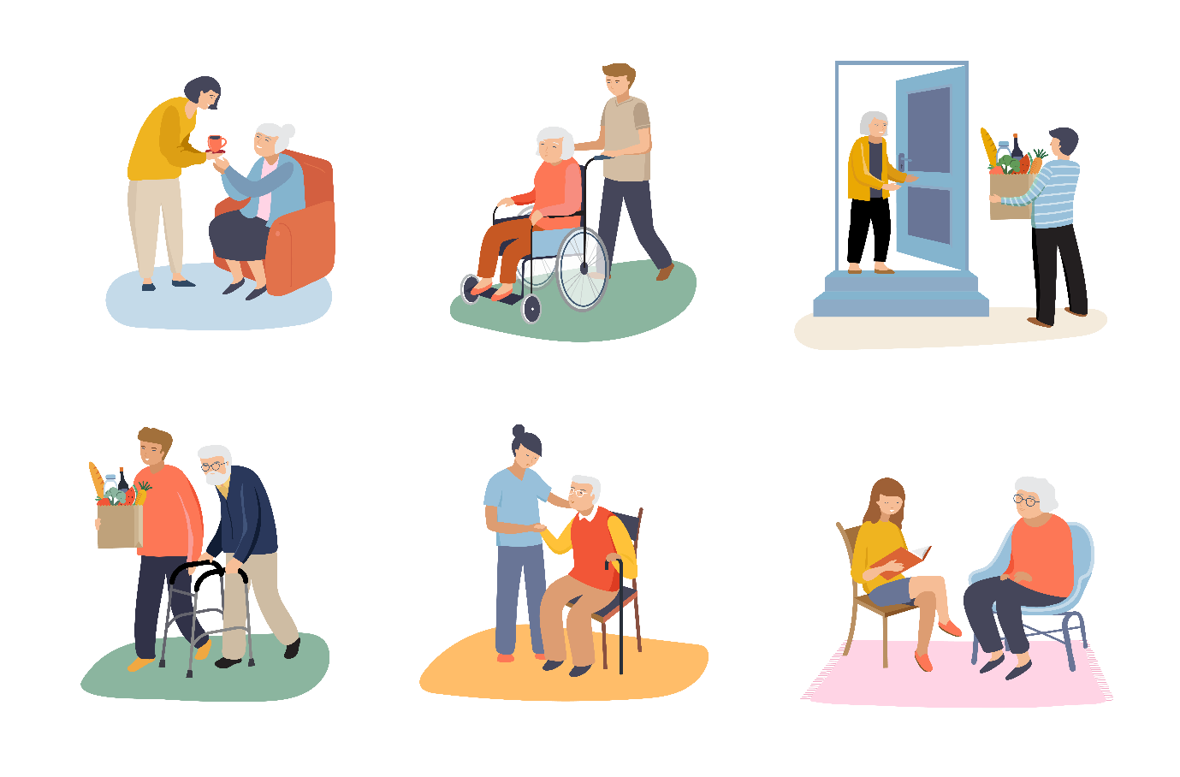A parent who regularly looks after   
their child with a disability;

A person who regularly looks after   
their older parents;

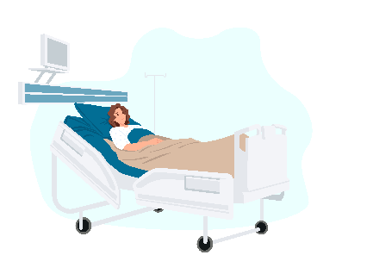A person who regularly looks after   
their partner who is sick.

Sadly, it is often women who are left alone   
to look after other family members.   
That is why most family carers are women.

### The situation in Europe

The role of family carers is very important.

Sadly, most countries in Europe do not recognise the important work of family carers

and give them little or no support.

In most countries in Europe, family carers:

* 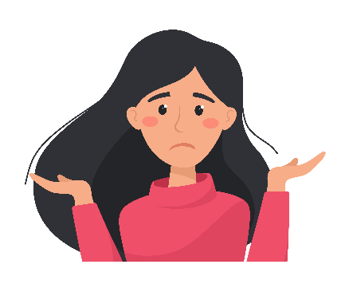Are not getting paid for their hard work.
* Cannot get another job,   
  because they have to look after   
  their family member who needs support.
* Do not get training to know   
  how to look after their family member   
  in the right way.
* Do not have the chance to take time off to rest.

### What should be done better

At COFACE, we believe that countries

should recognise the important role of family carers.

Countries should give family carers

the support they need to have a good life too.

Amongst others, countries should make sure that family carers:

* 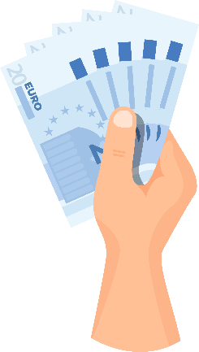Know about the rights and choices they have.   
  This way, family carers can choose   
  the support that is right for them.
* Get paid for the important work they do   
  to look after a person who needs support.
* Get time off their work   
  when they need a break.
* 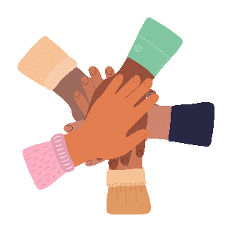Get training and learn how to look after   
  the person who needs support   
  in the right way.   
  These trainings should be planned   
  together with organisations of families,   
  family carers and the persons in need of support.   
  They are the ones who know their needs   
  the best.
* 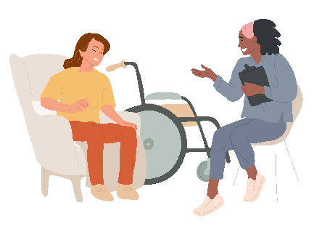Get the support they need   
  for free or without paying too much.   
  For example, family carers should be able   
  to hire someone to help them look after   
  the person in need of support.

All these things can make a big difference   
in the lives of family carers   
and the people who need support.

Countries should regularly check how things go and the progress made in these areas.

To do that, countries should ask for the views   
of organisations of families, family carers   
and the people who need support.   
They are the ones who know their needs best   
and can guide countries   
on the support they need.

### More information

If you want to know more   
about the work we do at COFACE,

you can check our website at:

[www.coface-eu.org](http://www.coface-eu.org/).

If you have any questions,

you can send us an email at:

[secretariat@coface-eu.org](mailto:secretariat@coface-eu.org).