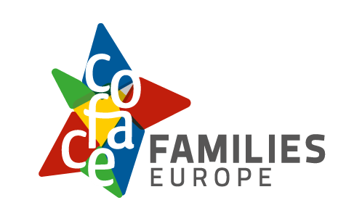

Our rules to make
our activities and events
safe for everyone


Easy-to-read version
Easy-to-read is information
that is written in a simple way
so that all people can understand it.
You can find more information at: www.inclusion-europe.eu/easy-to-read.

Who we are
We are ‘COFACE Families Europe’.
We are an organisation that fights
for the rights of all families in Europe.
In short, we are called ‘COFACE’.
At COFACE,
we believe that all families
should have the same chances
to enjoy a good, healthy and safe life.
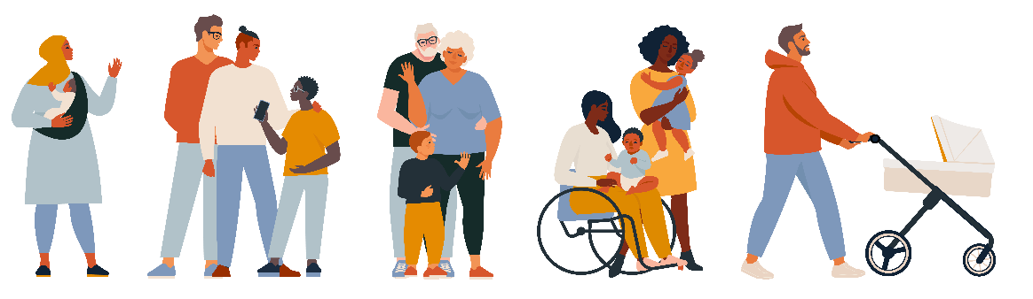

What this text is about

At COFACE,
we believe that all people should:
- Be kind to each other;
- Treat each other with respect;
- Not do anything that harms each other.


These beliefs are very important for us.
We want to apply these beliefs
in everything we do.
For this to happen,
we made a text that explains certain rules that everyone at COFACE must follow.

This text is called
‘Common Reference Framework’.
This is a version of this text
in easy language.
Our staff, our members
and everyone we work with COFACE
must agree to sign this text
and respect these rules.
In the next few pages,
we will explain more about these rules.

1. Create a safe space to work together
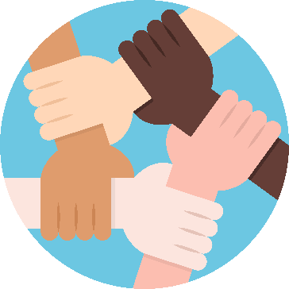
COFACE has different groups of people
who work together to make things better
for families in Europe:
The General Assembly
This is a big meeting
that happens every year.
All organisations that are part of COFACE
can join this meeting.
Together, we talk about
important topics for families in Europe
and plan our work to make things better.
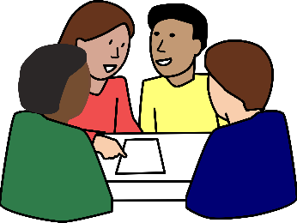

The Administrative Council
This is a group of people
who make decisions for COFACE.
They meet at least 3 times per year.
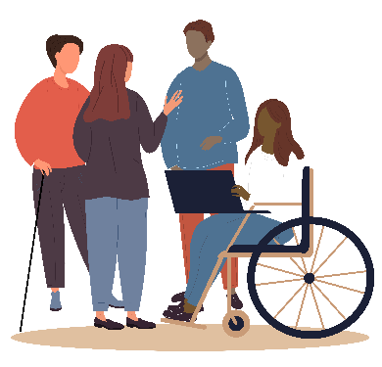
The Executive Bureau
This is a group of people who work
to make sure these decisions
are put into practice.
The Secretariat
This is a group of people who work
in our office in Brussels
and do the everyday work
of COFACE.
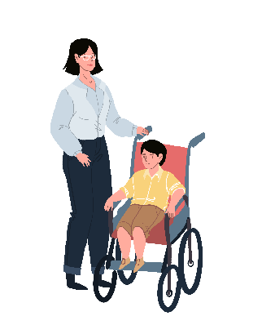
The COFACE Disability Platform
This is a group of organisations
that came together to make things better
for people with disabilities
and their families.
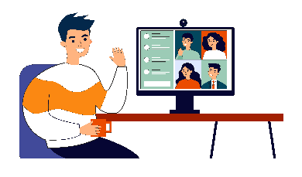
- The European Family Lab
This is a platform where
we organise online talks
and help people learn from each other
about important topics of families
in Europe.

COFACE wants to be
a safe and friendly place
for people to work together.
This is why all people who work for COFACE must agree to treat everyone
equally, kindly and fairly.

2. Respect everyone in meetings
At COFACE, we want everyone to feel
safe and welcome in our activities and events,
both in person and online.
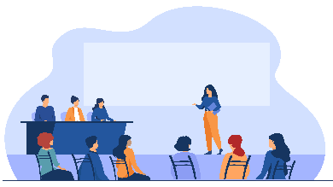
All people who take part
in our activities and events
must respect other people’s opinions
and be kind to each other.
They should never be rude,
attack or talk badly to others.
If someone needs to leave early,
they should do it in a calm way
without bothering the rest of the people.
Before each meeting,
we will always remind people of the rules.
We will also explain how to make a complaint if someone breaks these rules.

3. Help everyone to join in
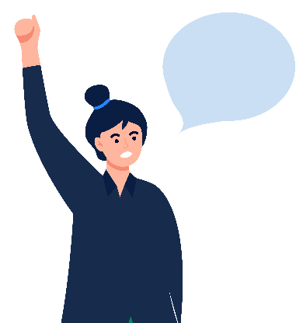
At COFACE, we want to make sure
that our events and activities
are easy for everyone to join.
Everyone can choose
how they talk about who they are.
For example, their gender, abilities,
family or anything else.

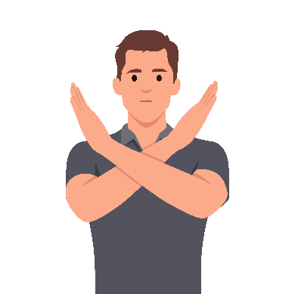
We do not allow anyone
to talk badly to another person
because of their disability, their skin colour,
or any other difference they may have.
We may all be different,
but we are all equal.

3. Keep children safe
When children join our events and activities, we follow special rules to keep them safe.
We must always ask parents for their permission and treat children with respect
at all times.
When taking photos and videos,
we should never show the faces of children.

4. Do not allow bad or unfair behaviour
Treating people badly or unfairly
is not allowed at COFACE.
Nobody has the right to hurt another person and make them feel scared and unsafe.
We do not allow anyone
to talk badly to another person
because of their disability, their skin colour, their gender, who they love
or any other difference they may have.

5. Keep everyone safe from sexual harm
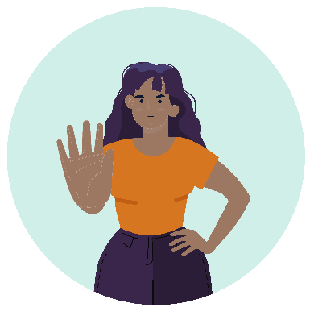
At COFACE, no one is allowed
to make others feel uncomfortable or unsafe in a sexual way.
For example, no one is allowed
to touch or speak to another person
in a way that makes them uncomfortable.
This behaviour is never okay.
Adults must never have sexual contact
with children.
People who work for COFACE
should never buy sexual services
or use porn during work.
Everyone must behave with respect
and keep others safe.

6. Do what is right for COFACE
People who work for COFACE
must always do what is best for COFACE and families in Europe.


They should not make decisions for COFACE based on their own interests
or the interests of their friends and family.
For example,
a person who works for COFACE
should not hire someone
just because they are friends or family.

7. Do not abuse power
People who have the power
to make decisions for COFACE
should never use it to harm other people.
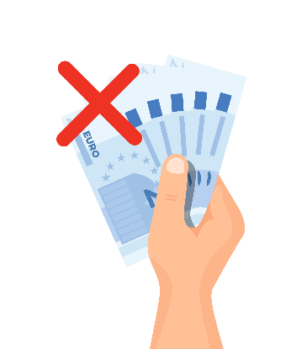
Just because a person has a higher job
does not mean they have the right
to treat others badly or unfairly.
They should also not use their power
to get benefits for themselves.
For example,
they should not try to get themselves
more money than what is fair.

8. Treat information carefully
At COFACE, we try to be open and clear about how we work,
where we get our money from
and all the activities we do.

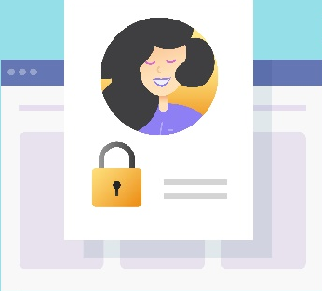
Some information is private,
like personal details
about our staff and members.
We should keep private information safe
and only share it
when it is allowed and necessary.

9. Stay away from alcohol and drugs
People working for COFACE
are not allowed to use drugs.
While working,
they are also not allowed
to drink much alcohol.
Getting drunk can make people behave badly and can harm our organisation.
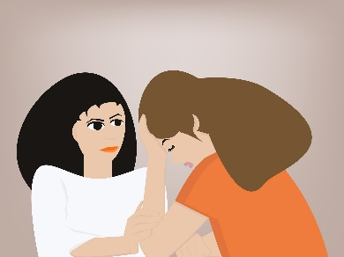
A small drink is only allowed
at special events.
If someone has problems
with alcohol or drugs,
COFACE will try to help them
with care and support.

What if people do not respect these rules
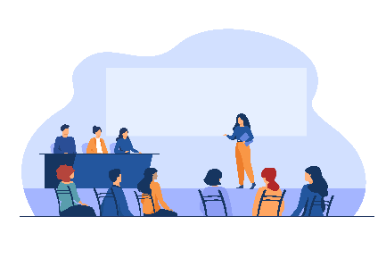
These rules are very important to us.
If we all respect these rules,
our events and activities
will be a safe space
for everyone to join in.
If someone treats others
in a bad or unfair way
during our events or activities,
we will first remind them of our rules.
We may also ask them to say sorry
or even leave the meeting.
We may also stop working with people
who do not respect our rules.
If someone hits or attacks someone,
we will stop any activity,
make sure everyone is safe,
and call the police if needed.

How to tell us if something bad happens
We are here to help you,
if you or someone else:
Feels hurt or unsafe;
Are treated unfairly;
while taking part in our activities or events.
To tell us what happened and ask for help,
you can do one of these things:

You can fill in a form on our website
by clicking here.
You can talk to the Director of COFACE.
Her name is Elizabeth Gosme.
You can talk to her in person
or send her an email at:
lgosme@coface-eu.org.
If your complaint is against the Director,
you can talk to the President
of our Executive Bureau.
Her name is Antonia Torrens.
You can send her an email at:
torrens@kmop.org.
We are always here
to listen to what happened
and make sure this does not happen again
in our events and activities.

More information
You can find more about
the work we do at COFACE
in simple language
on our website by clicking here.
You can also find the full text of our rules
by clicking here.
The full text is harder to understand
so you may need to read it
together with another person.

