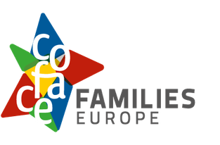
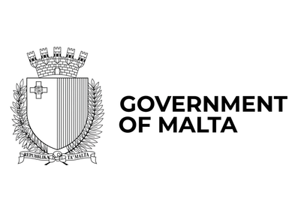
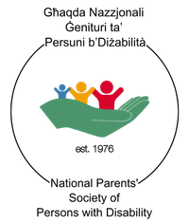
Our event on
the European Child Guarantee
for children with disabilities
18 November 2026


Information and programme
in easy-to-read
Easy-to-read is information
that is written in a simple way
so that all people can understand it.
You can find more information at:
www.inclusion-europe.eu/easy-to-read.

Some difficult words in the text are marked in bold black.
You can find their explanation at the end of this booklet.

Information about the event

What the event is about
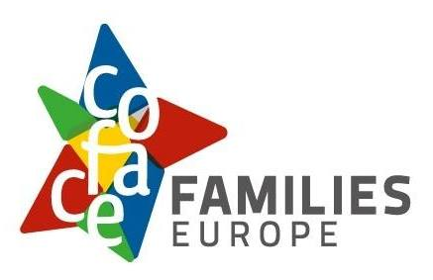
We are ‘COFACE Families Europe’.
We are an organisation that fights
for the rights of all families in Europe.
In short, we are called ‘COFACE’.
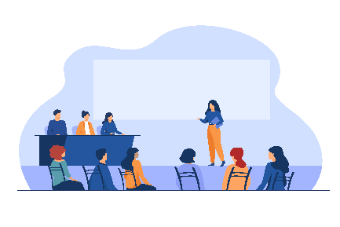
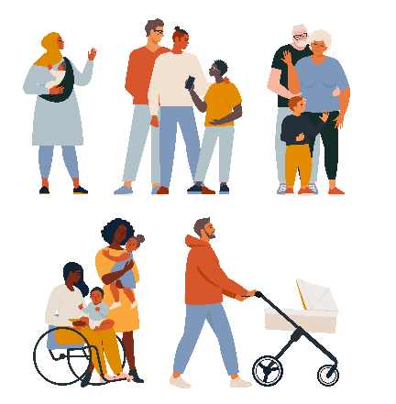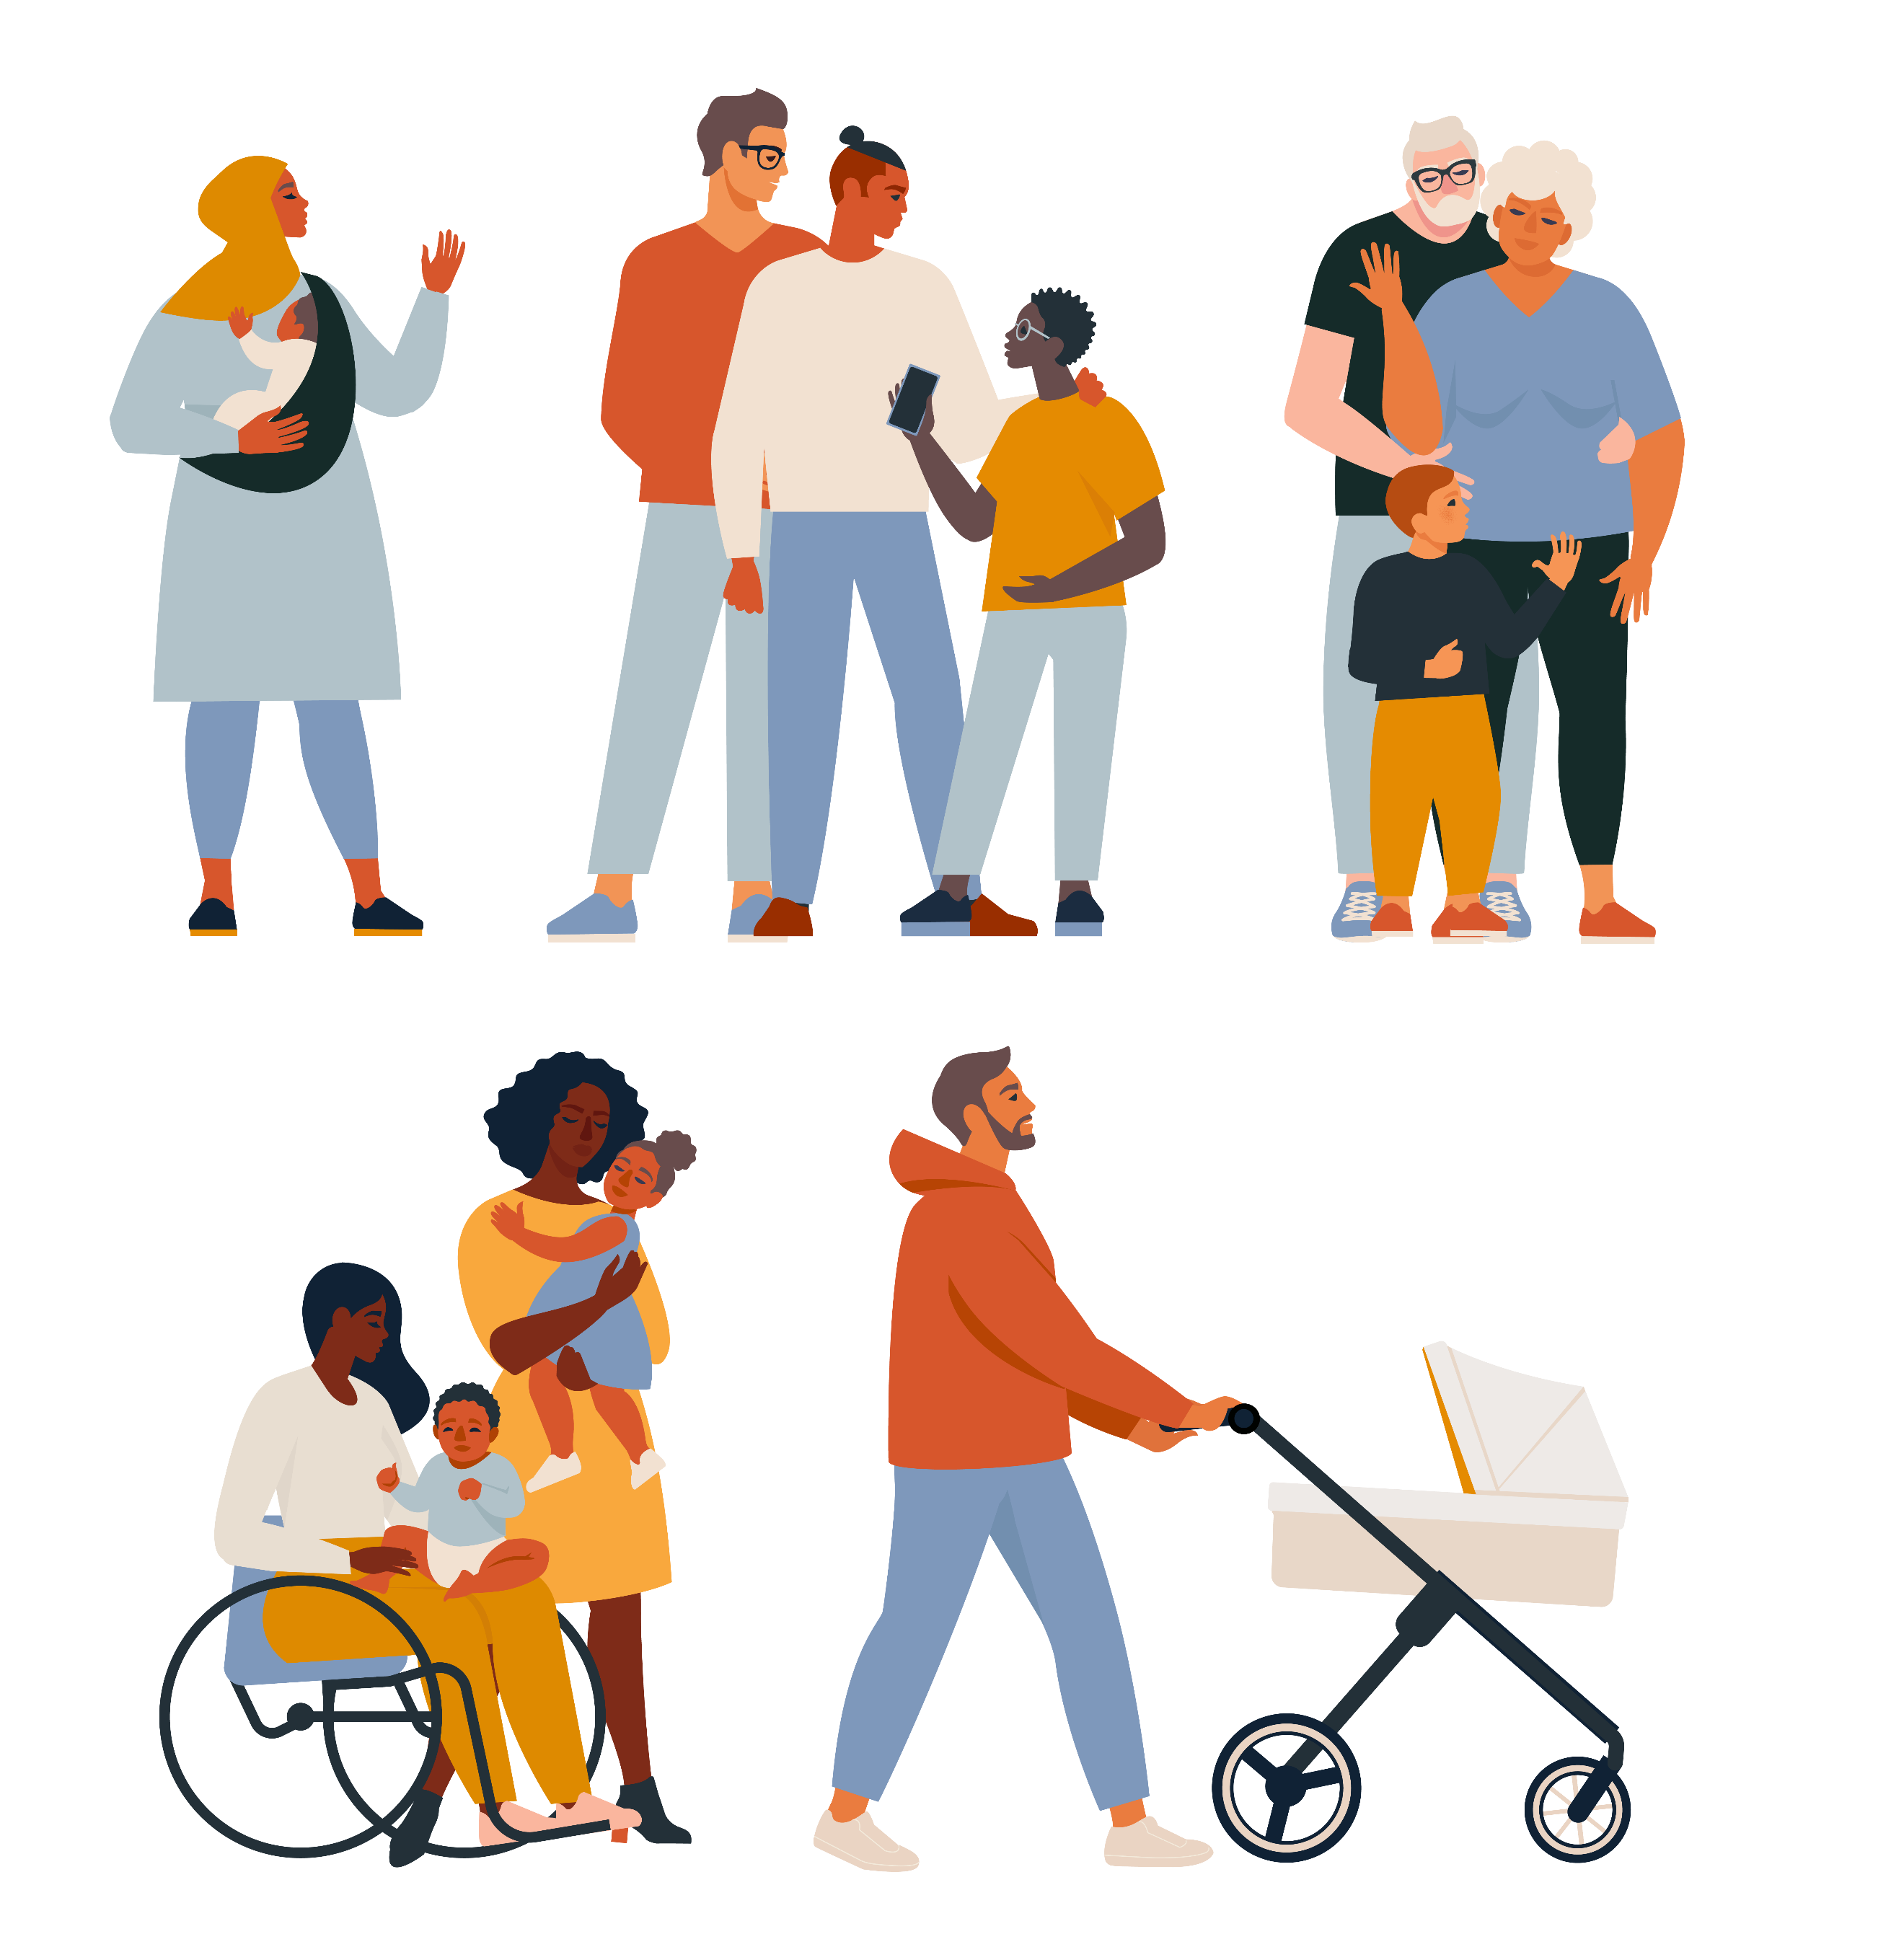
On 18 November 2026,
we organise an event in Malta.
We organise this event together with:
- People from the government of Malta.
- The ‘National Parents’ Society
of Persons with Disabilities’.
This is an organisation
that stands for the rights
of people with disabilities and their families
in Malta.

In the event,
we will discuss how to make
the ‘European Child Guarantee’ happen
and make things better
for children with disabilities
and all children.

What the European Child Guarantee is
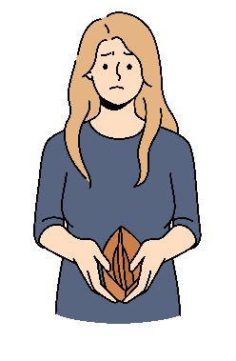
The European Child Guarantee is
a plan that the European Union made
to help children in need.
For example, children from poorer families
who do not have the money to live well.
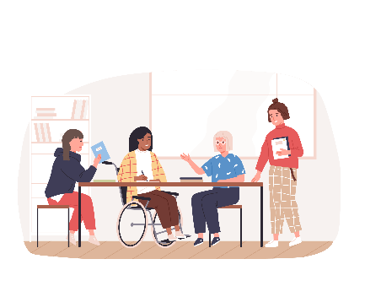
The aim of the European Child Guarantee is
to make sure that all children in Europe can:
- Go to school for free;
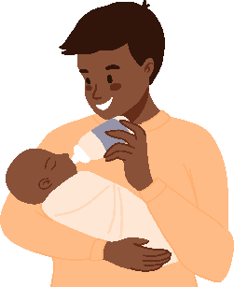
- See a doctor and get better
when they are sick;
- Have good food and be healthy;
- Have a safe home to live in.
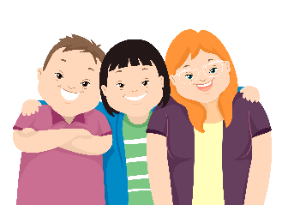
The European Child Guarantee is important
for children with disabilities too.
Children with disabilities are often left out.
Also, their families may not have enough money
to get the support they need.
In our event, we will discuss:
- How to make the European Child Guarantee
happen for children with disabilities too;
- What countries in Europe do
to support children with disabilities
and their families;
- What can be done better.

Other meetings

Apart from the main event on 18 November,
there will be some more meetings
before and after the event.

On 17 November,
there will be a meeting of the people
who are part of the ‘COFACE Administrative Council’.
This is the group of people
who make decisions for COFACE.
If you are not part
of COFACE Administrative Council,
you will not take part in this meeting.
On 19 November, there will be 2 more meetings:

- A meeting with people who work
for the Government of Malta
and other countries
to discuss how to give
better support to families.
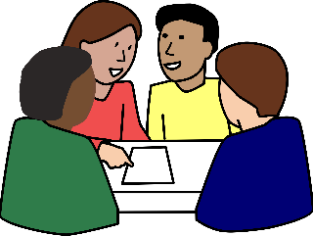
- An annual meeting
of the ‘COFACE Disability platform’.
This is a group that COFACE has made
to support the rights
of children with disabilities
and their families.

The programme of the event
There will be 1 person who will help guide the discussions
during the event:
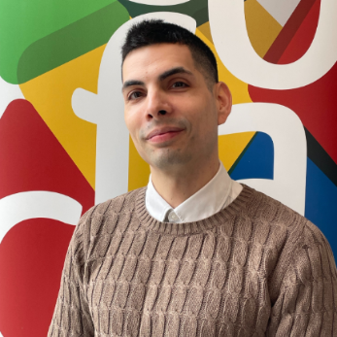
Sebastian Gonzalez
Sebastian works for ‘COFACE’.
COFACE is an organisation
that fights for the rights
of all families in Europe.



09:00 - 09:30 Registration and coffee
Please pass by our counter to get your badge.
This is a card with your name on.
Then, feel free to enjoy a coffee before the event starts.

09:30 - 10:15 Welcome
In this part, the speakers welcome people to the event
and talk about the discussions that will take place during the event.
The speakers of this part are:
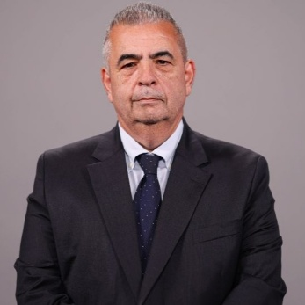
Michael Falzon
Michael is part of the government of Malta.
His work is to make plans that support families
and people in Malta.
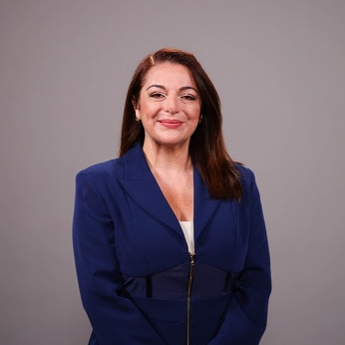
Julia Farrugia
Julia is also part of the government of Malta.
Her work is to make sure that
people with disabilities and all people in Malta
can take part in society without problems.
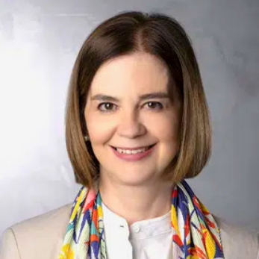
Antonia Torrens
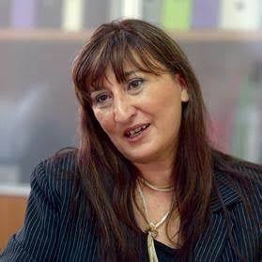
Antonia is the President of ‘COFACE’.
COFACE is an organisation
that fights for the rights
of all families in Europe.
Marchita Mangiafico
Marchita is part of the ‘National Parents’ Society
of Persons with Disabilities’.
This is an organisation that stands for the rights
of people with disabilities and their families
in Malta.

10:15 – 11:00 Making the European Child Guarantee stronger for children with disabilities
In this part,
the discussion is about how to make
the European Child Guarantee stronger
for children with disabilities and all children.

As we said before,
the European Child Guarantee is
a plan that the European Union made
to protect children in need.
If this plan happens,
it will help children with disabilities and their families too.
The speaker of this part is:
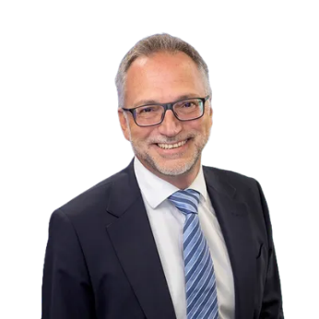
Massimiliano Mascherini
Massimiliano works at ‘Eurofound’.
This is an organisation that studies
how people live and work in Europe.


11:00 - 11:30 Break
Have a break and enjoy a coffee!

11:30 - 12:30 Group discussions on challenges
for children with disabilities and their families
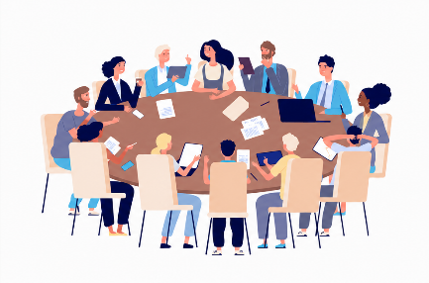
In this part, we will split into smaller groups.
In each group, people will talk together
about the challenges for children with disabilities
and their families.
We can share our experiences
and learn from each other.

12:30 – 13:00 Back together
In this part, we will gather all together again.

A person from each group will present
a list of the challenges
they talked about in their group.


13:00 – 14:00 Lunch break
Enjoy your lunch
and see you back at 14:00!

14:00 – 15:30 Group discussions on what support exists
for children with disabilities and their families
In this part, we will split again
into 4 smaller groups.
In each group, speakers will talk about
what support children with disabilities
and their families
get in different countries in Europe.
- Group 1 will focus on Hungary and Norway.
- Group 2 will focus on France and Greece.
- Group 3 will focus on Malta and Belgium.
- Group 4 will focus on Portugal and Spain.
You can choose which group you want to join.

Group 1: Hungary and Norway
The speakers of this group are:
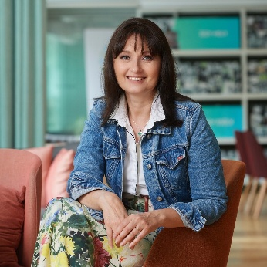
Anna Nagy
Anna works for ‘Egyszulo’ in Hungary.
This is an organisation that supports single parents
who raise their children
without the help of a partner.
Anna will speak about how the situation is
for single parents of children with disabilities
in Hungary.
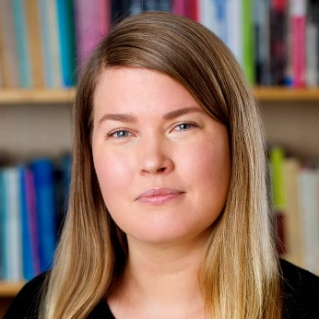
Kaja Larsen Østerud
Kaja works as a researcher
in the ‘Oslo Metropolitan University’ in Norway.
Kaja will speak about how services in Norway
work together to help children with disabilities
and their families.

Group 2: France and Greece
The speakers of this group are:
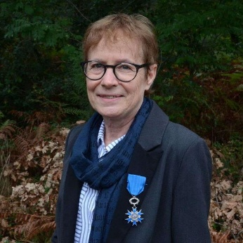
Chantal Bruno
Chantal is part of ‘APF France Handicap’.
This is an organisation that fights for the rights
of people with disabilities and their families
in France.
Chantal will speak about how families
of children with disabilities
support each other in France.
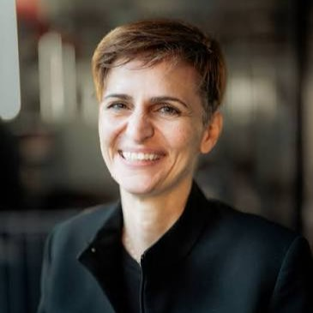
Agapi Papadaki
Agapi is part of ‘Disability Support Europe’.
This is an organisation that works
to make sure that people with disabilities
get the support they need to live independently.
Agapi will speak about how early support helps
young children with disabilities and their families
in Greece.

Group 3: Malta and Belgium
The speakers of this group are:
Marchita Mangiafico
Marchita is part of the ‘National Parents’ Society
of Persons with Disabilities’.
This is an organisation that stands for the rights
of people with disabilities and their families
in Malta.
Marchita will speak about
how inclusive education is in Malta.
Inclusive education means
that children with disabilities can go to school
together with other children.
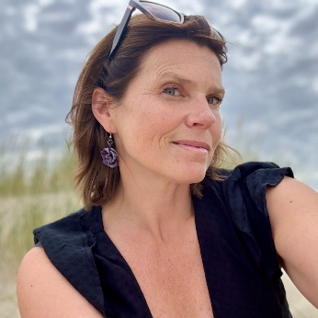
Iwona Suska and Darline Bogaert
Iwona and Darline are part of
‘Ouders voor inclusie’.
This is an organisation of parents
of children with disabilities in Belgium.
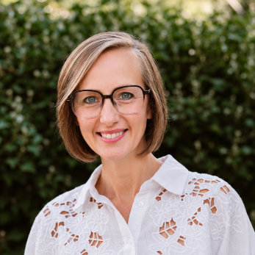
Iwona and Darline will speak about
how inclusive education is in Belgium.
Inclusive education means
that children with disabilities can go to school
together with other children.

Group 4: Portugal and Spain
The speakers here are:
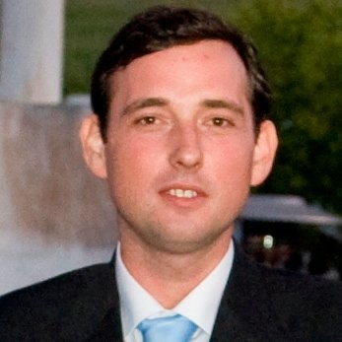
Gonçalo Solla
Gonçalo works for ‘Fundaçao Liga’ in Portugal.
This is an organisation that supports
people with disabilities in Portugal.
Gonçalo will speak about
how children with disabilities in Portugal
can get the healthcare they need.
Like seeing a doctor or going to the hospital.
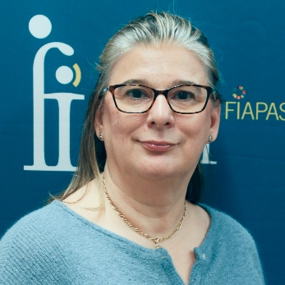
Natalia Beraza
Natalia works for ‘FIAPAS’ in Spain.
This is an organisation of families
of deaf people in Spain.
Natalia will speak about how
early support and hearing tests
can help deaf children in Spain.

15:30 - 16:30 Conclusions and end of the event
In this part, we will gather all together again
and share some conclusions and thoughts.
After the end of the event,
people can stay, talk to each other
and get to know new people.
Thank you for taking part in our event!

Explanation of difficult words

European Union
The European Union is a group of 27 countries in Europe.
These countries work together to make things better for their people.
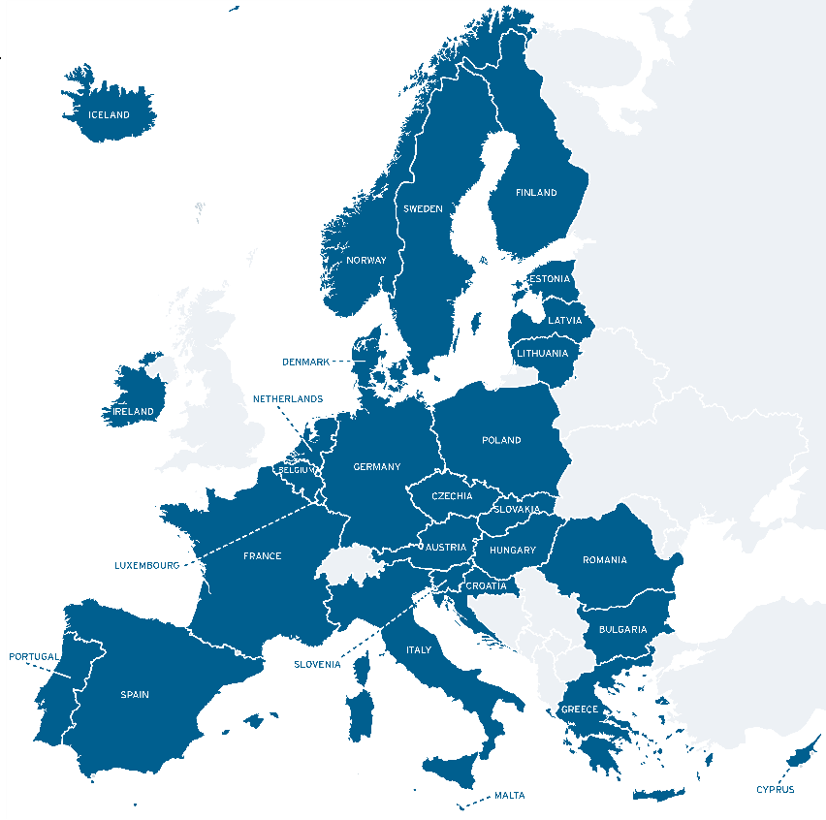

Government

A government is a group of people
that make decisions on how to run a country.
All people in a country vote and choose
the government they want
to stand for their rights.

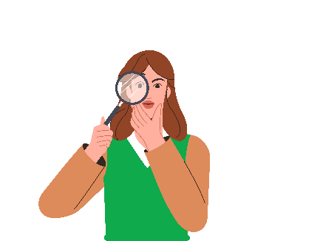
Researcher
A researcher is someone
whose job is to study a topic carefully
and find new information
on this topic.

